LAB 8
NAME: Hajra Sarwar REG NO: 2023-BSE-022
CLASS: BSE-5A
SUBJECT: CC

LAB TITLE: AWS: Account Setup, IAM, VPC Inventory, EC2, Docker & Gitea

TASK:

Task 1: Create AWS Root Account & Enable UAE Region
Goal:
Create a new AWS root account and enable the me-central-1 (UAE) region.
Steps:
- Opened the browser and navigated to the AWS Signup page.
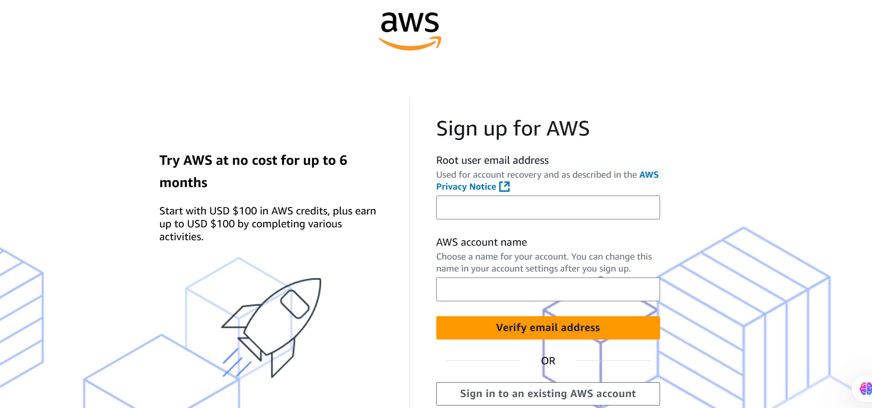
- Completed registration:
  - Account type: Personal
  - Plan: AWS Paid Plan
  - Entered billing and phone verification details
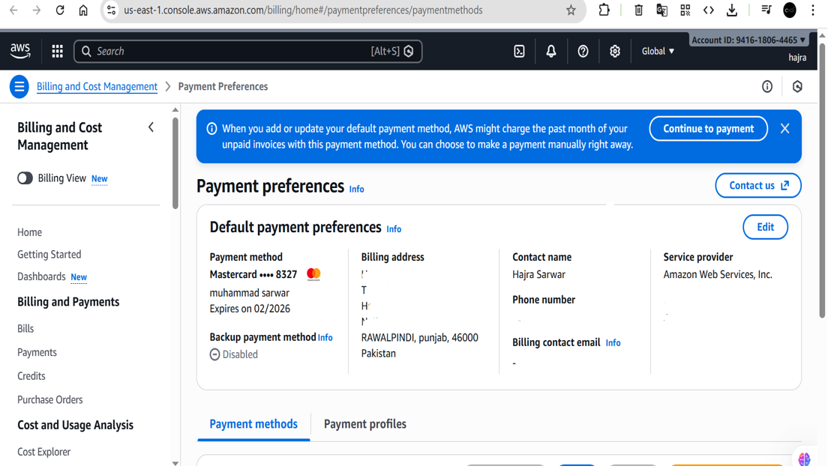
- Signed in using the root email.
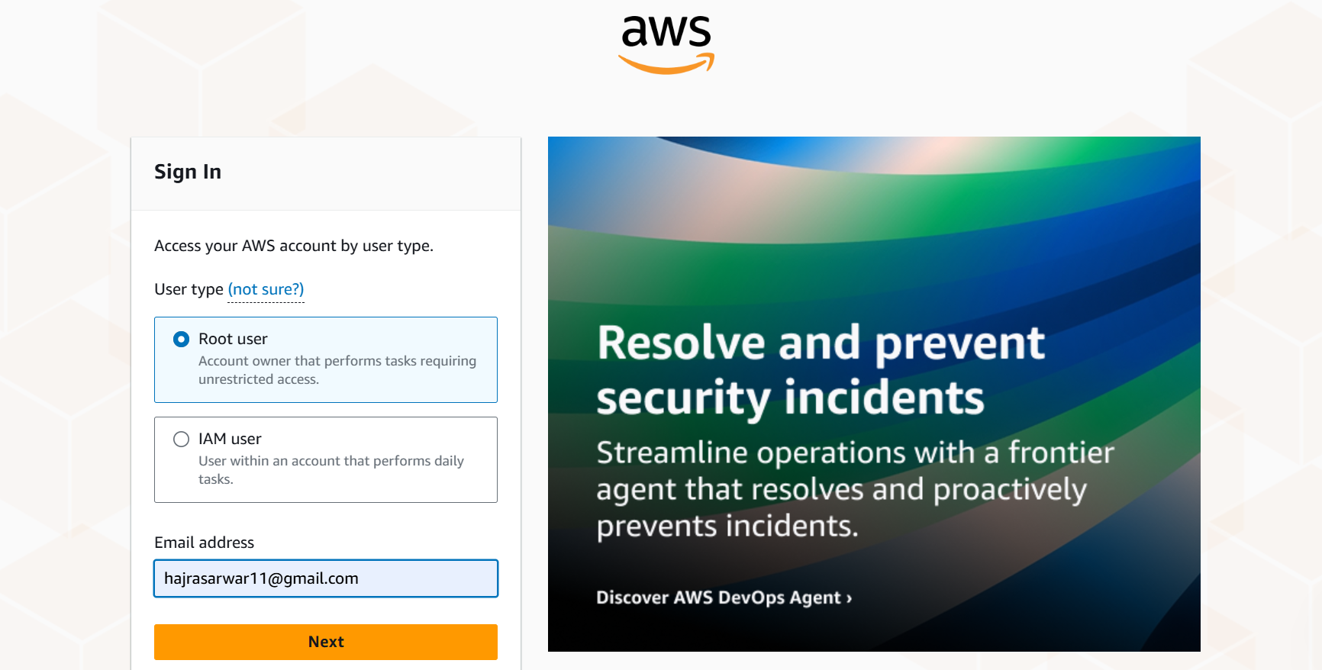
- Opened the region selector from the AWS Console.
- Enabled and switched the region to Middle East (UAE) – me-central-1.
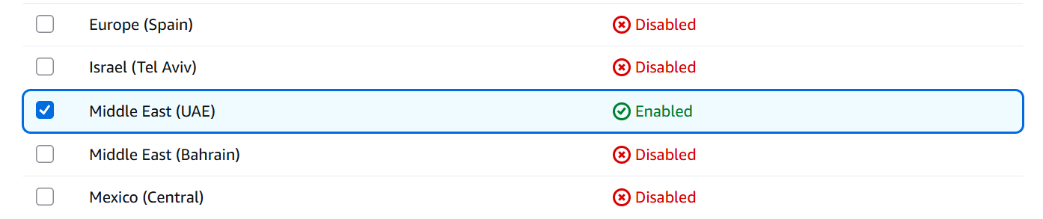
- Task summary screenshot showing root login and UAE region enabled.
Outcome:
AWS root account was successfully created, and the UAE region was enabled and selected.

Task 2: Create IAM Admin & Lab8User
Goal:
Create IAM users with AdministratorAccess and verify logins.
Steps:
A. Creating Admin User (as Root)
- Opened IAM Console from AWS services.
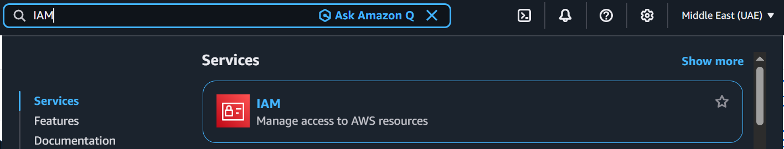
- Created a new user:
  - Username: Admin
  - Enabled AWS Management Console access
  - Attached AdministratorAccess policy
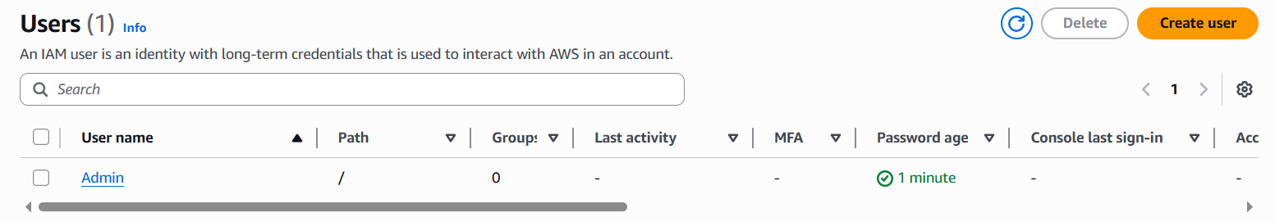
- Downloaded the Admin credentials CSV.
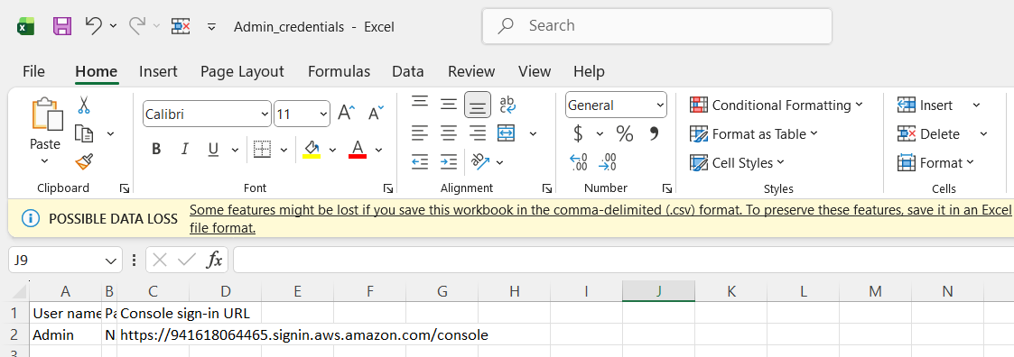
- Logged out from root account.
B. Login as Admin & Create Lab8User
- Logged in using Admin credentials.
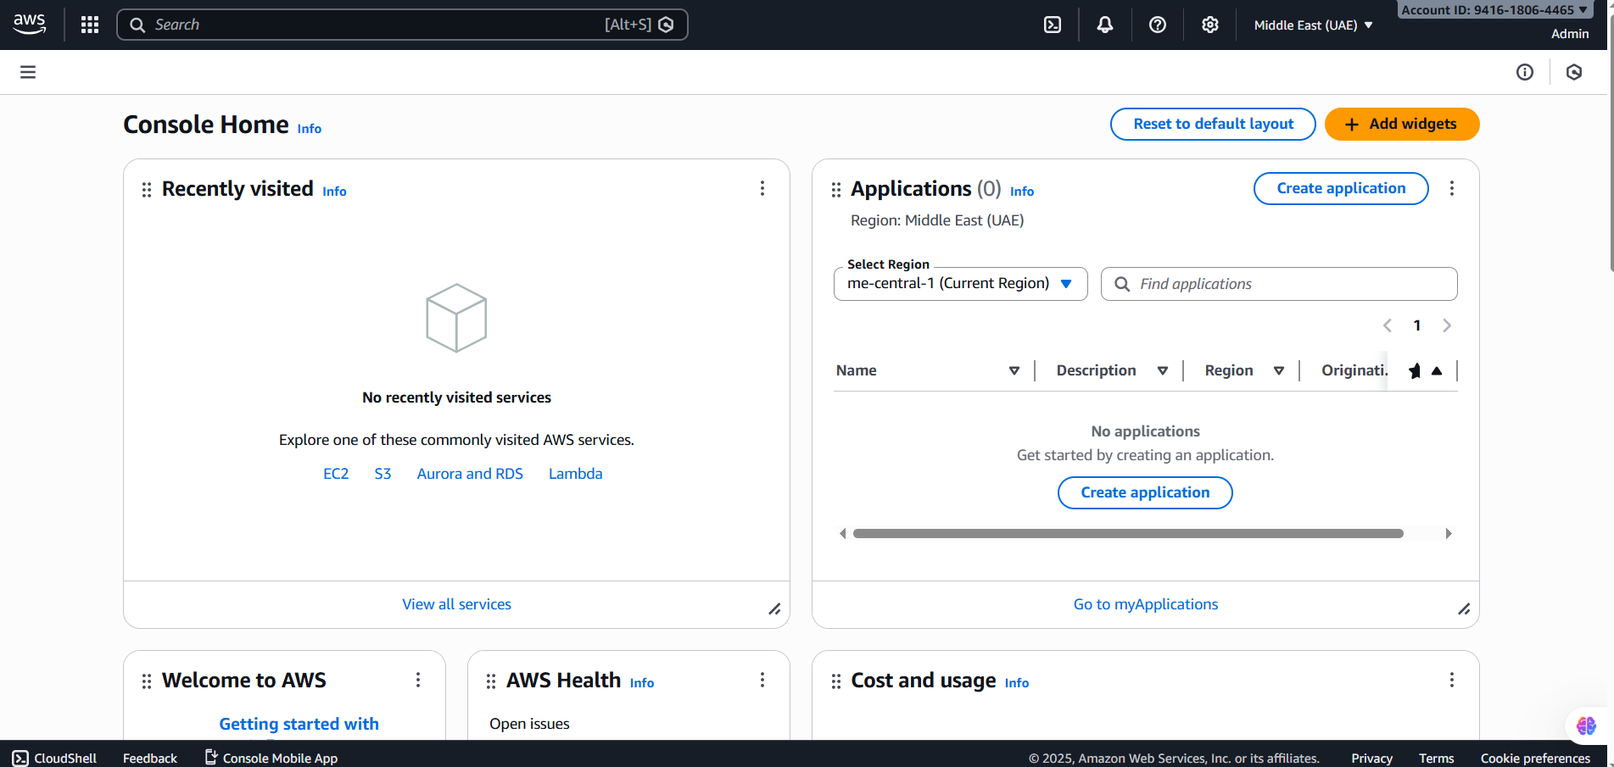
- Created another IAM user:
  - Username: Lab8User
  - Console access enabled
  - Attached AdministratorAccess
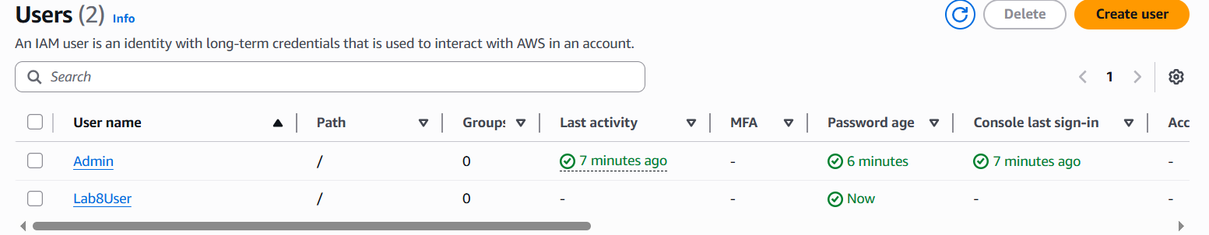
- Downloaded Lab8User CSV.
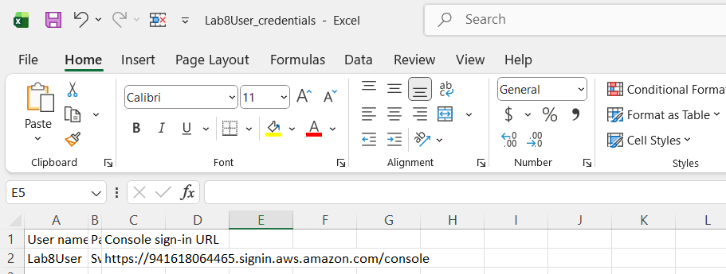
- Logged in as Lab8User.
- Task summary screenshot showing both IAM users.
Outcome:
IAM users Admin and Lab8User were created successfully and verified through login.

Task 3: Inspect VPC Resources (UAE Region)
Goal:
Explore default VPC components in the UAE region.
Steps:
- Opened VPC Console.
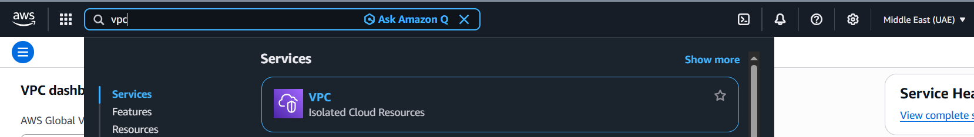
- Viewed VPCs list.
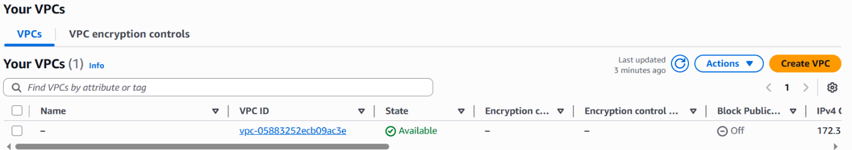
- Viewed Subnets list.
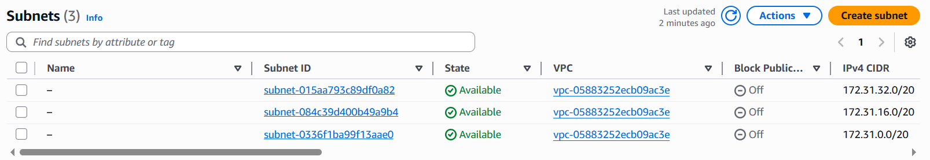
- Viewed Route Tables list.
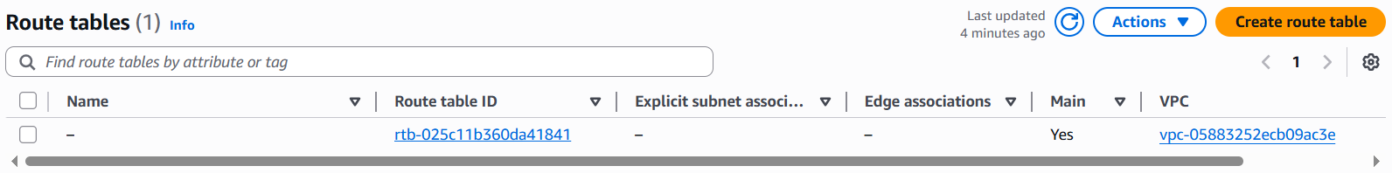
- Viewed Network ACLs list.
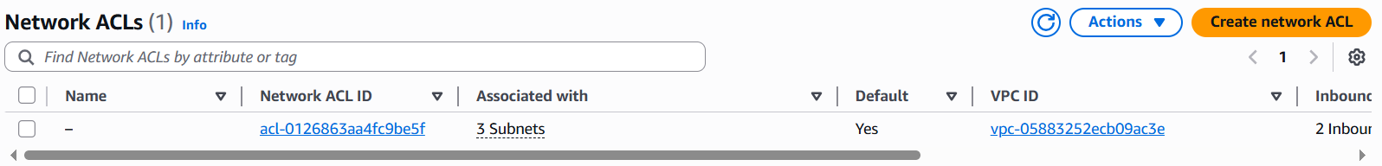
- Task summary showing all VPC resources.
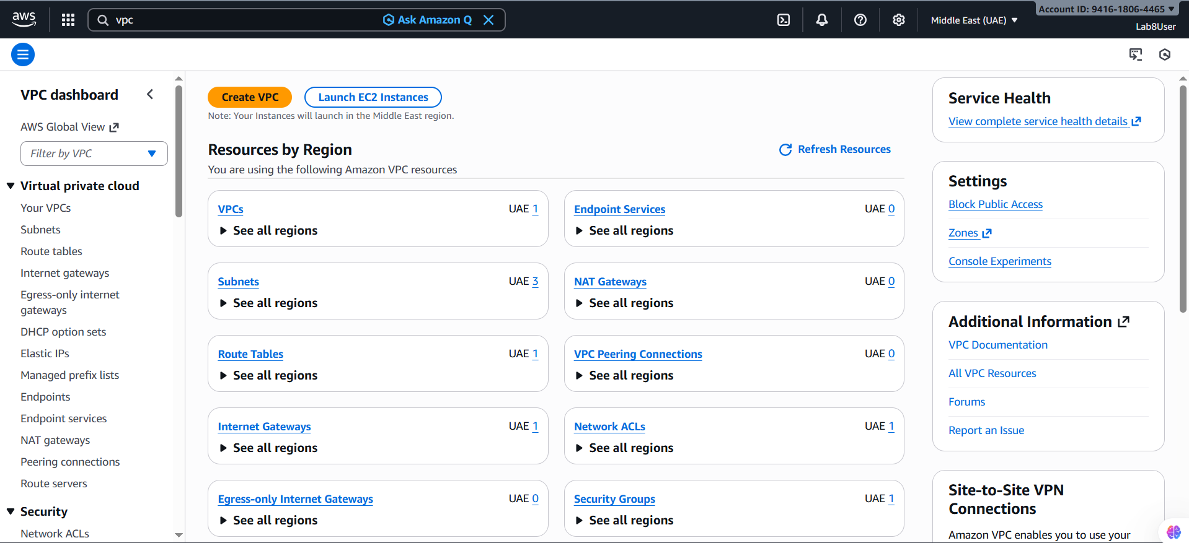
Outcome:
All default VPC resources in the UAE region were successfully inspected.

Task 4: Launch EC2, Install Docker & Deploy Gitea
Goal:
Launch an EC2 instance, connect via SSH, install Docker, and deploy Gitea.
Steps:
A. Launch EC2 Instance
- Opened EC2 Console.
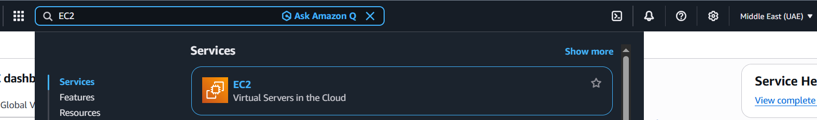
- Launched a new instance:
  - Name: Lab8Machine
  - AMI: Amazon Linux 2
  - Instance type: t3.micro
- Created Security Group: Lab8SecurityGroup (SSH allowed from My IP)
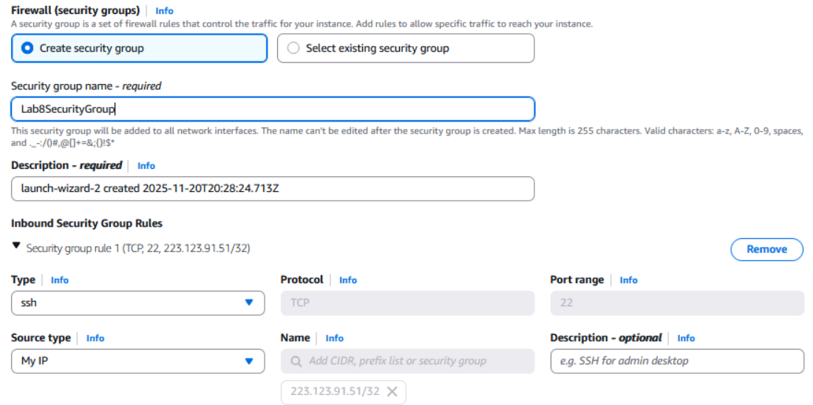
- Created Key Pair: Lab8Key (ED25519, .pem) and downloaded it.
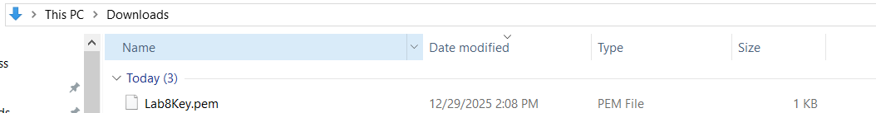
- After launch, EC2 Instances list showing Lab8Machine in "running" state and public IPv4 visible.
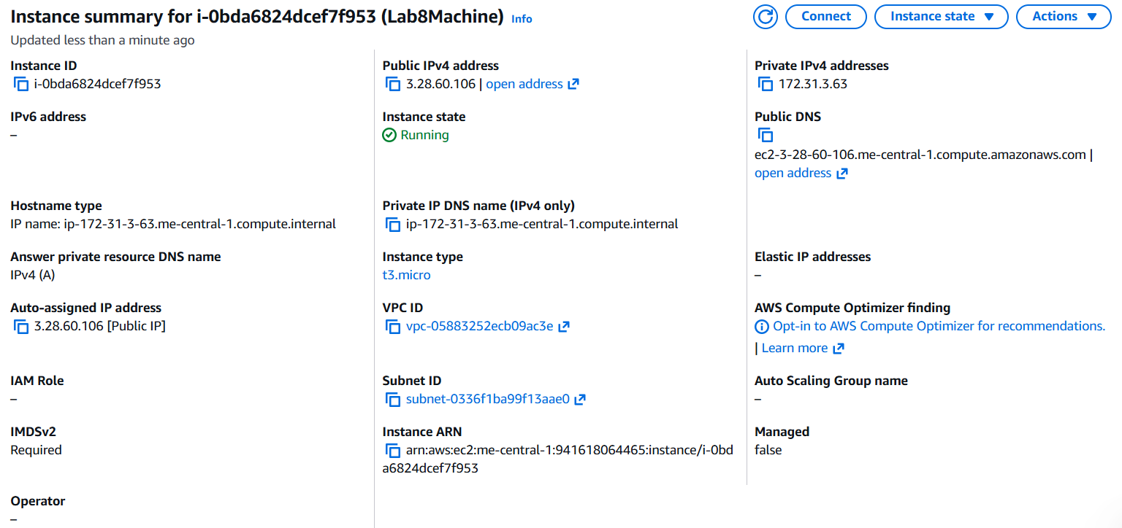
B. SSH into EC2
- Connected from Windows host using:
ssh -i Lab8Key.pem ec2-user@<Public-IP>
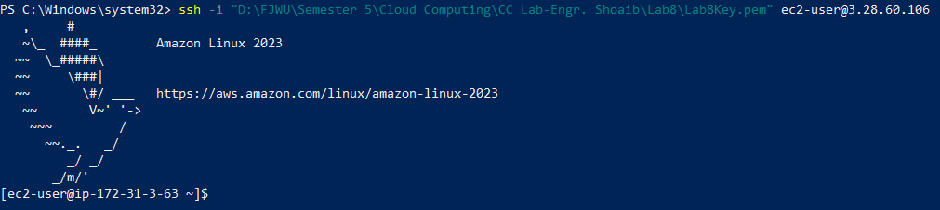
C. Install Docker & Docker Compose
- Ran installation commands and started Docker service.
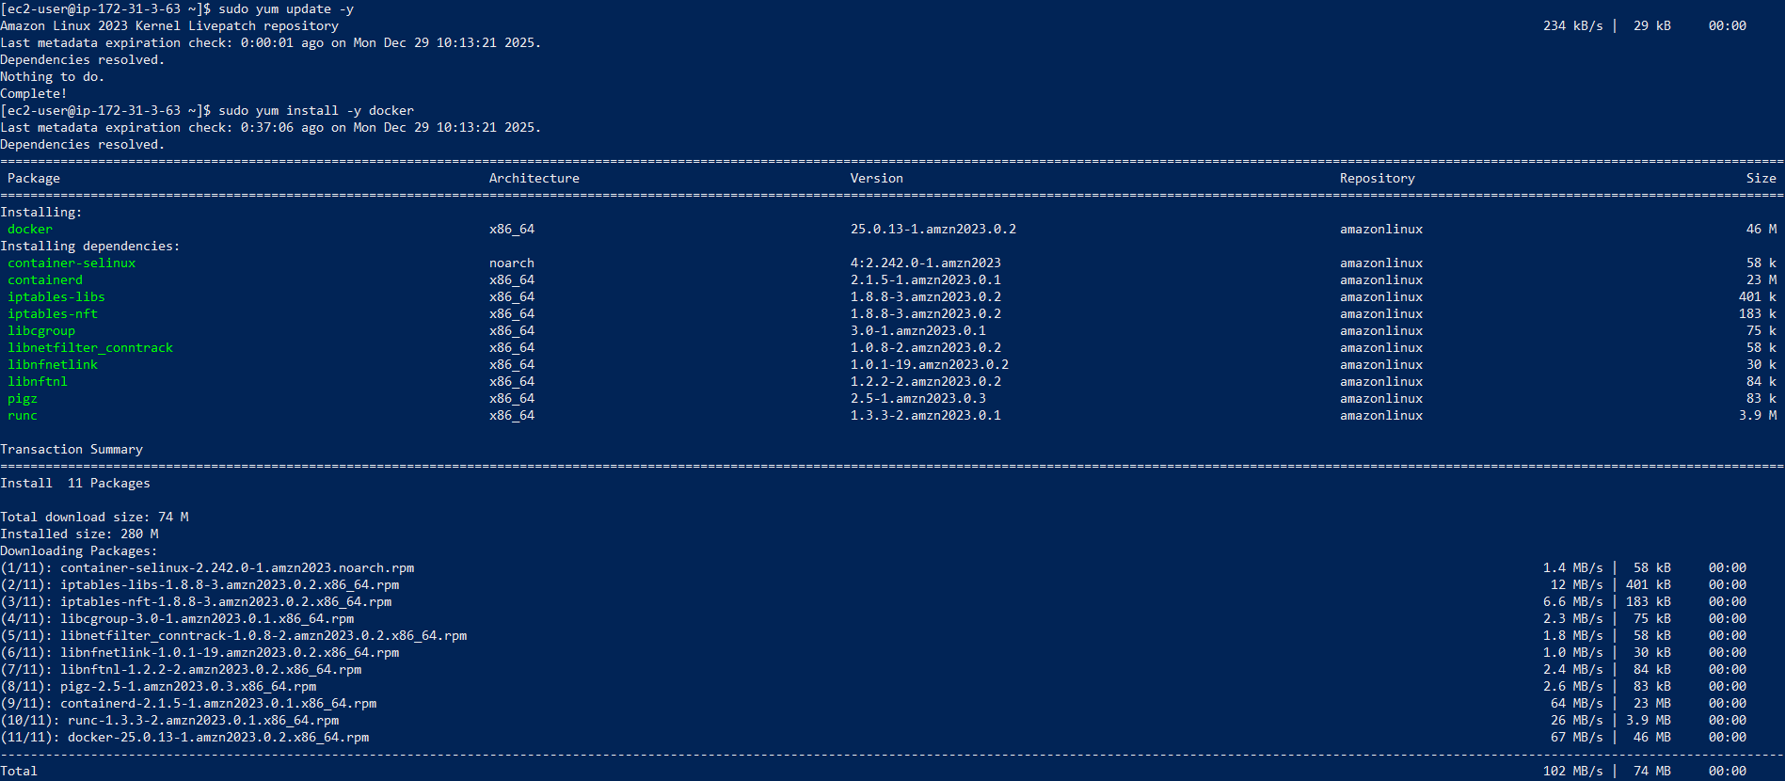
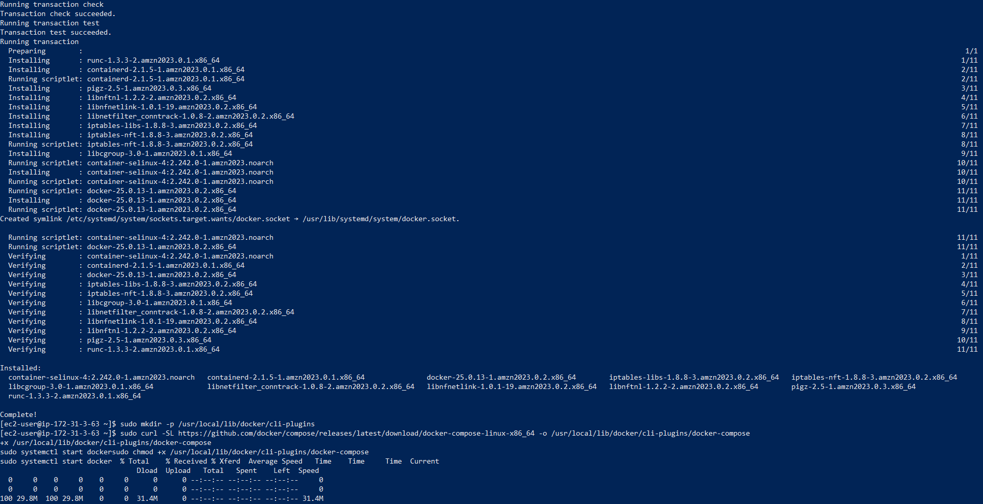
D. Deploy Gitea
- Created compose.yaml and pasted Gitea configuration.
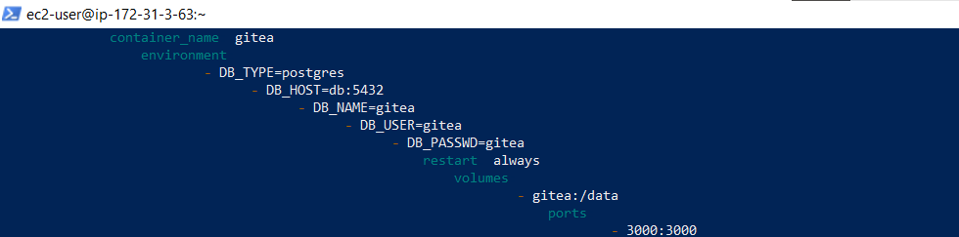
- Verified compose.yaml file exists.
- Added user to docker group and reconnected.
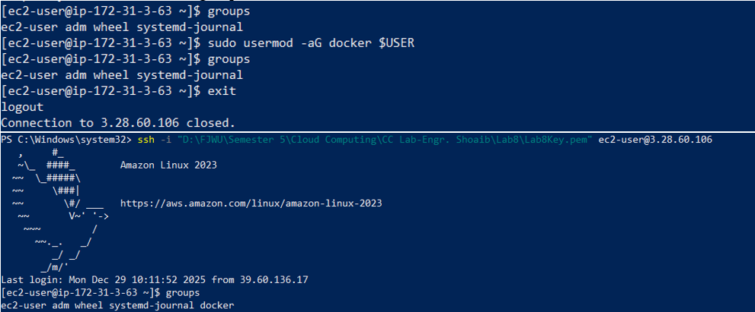
- Ran docker compose up -d.
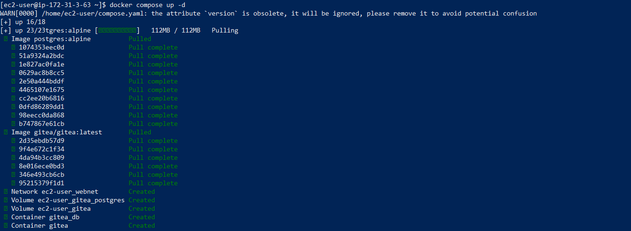
- Edited Security Group inbound rules to allow port 3000.
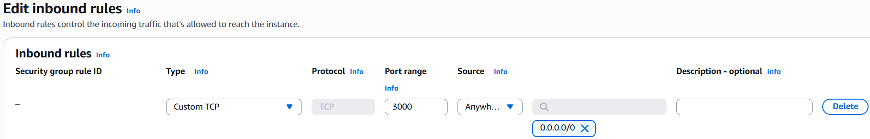
- Accessed Gitea using browser, run http://3.28.60.106:3000/ and completed setup.
Install page:
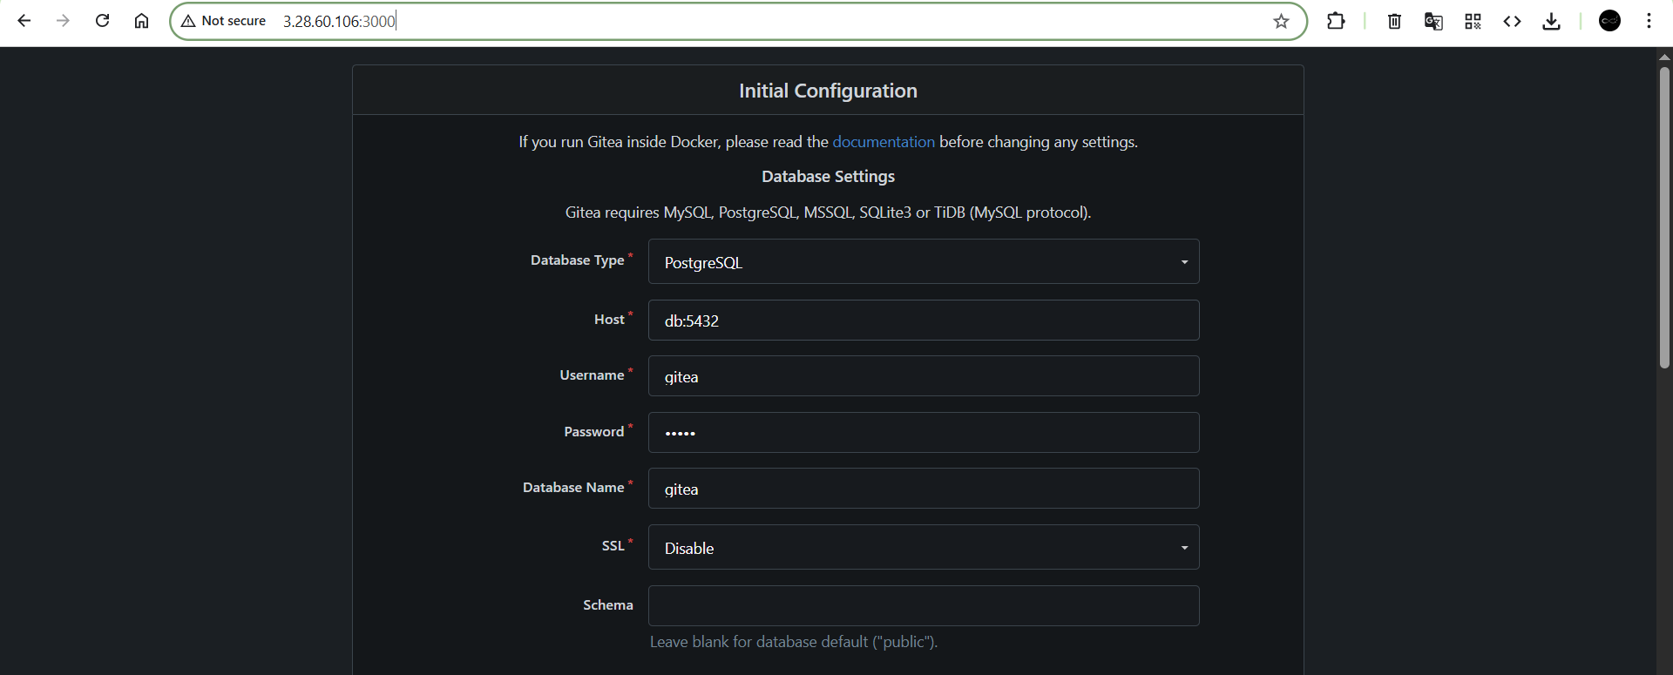
Repo page:
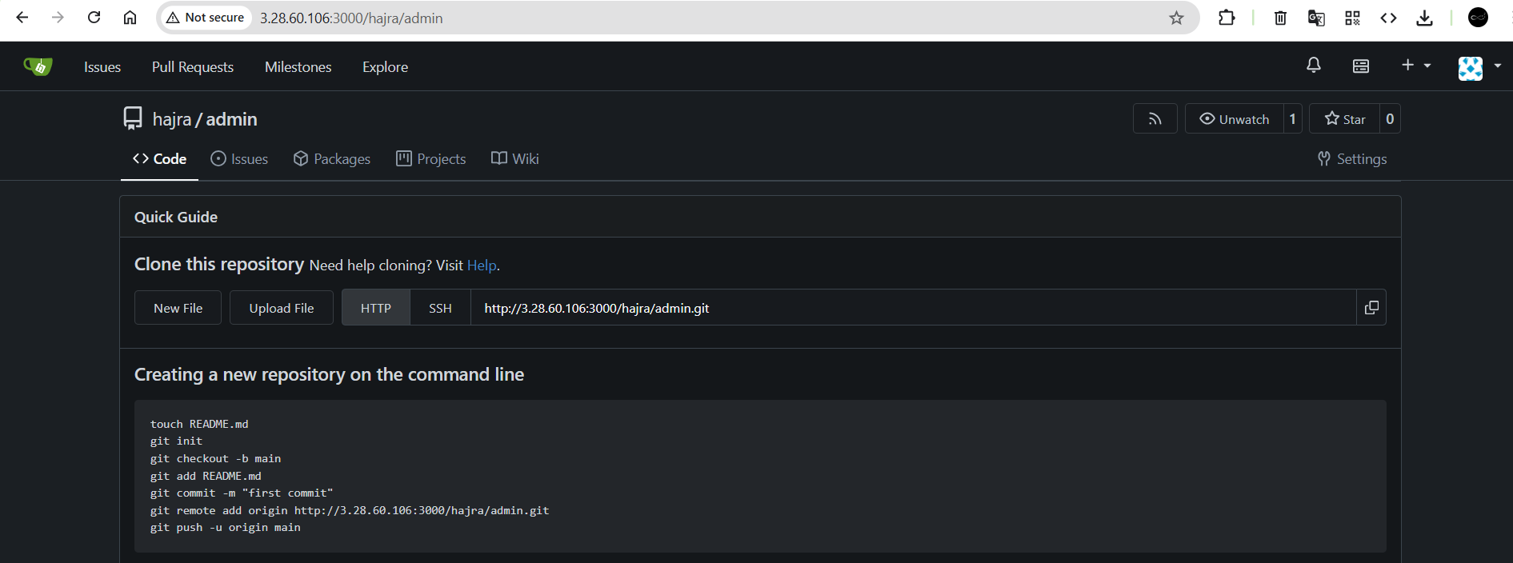
- Task summary showing EC2, security group, and Gitea UI.
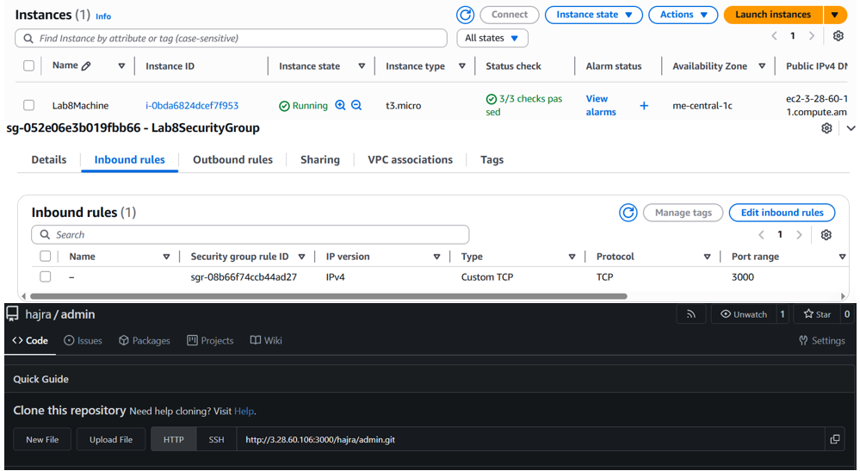
Outcome:
EC2 instance launched, Docker installed, and Gitea deployed successfully.

Cleanup: Remove AWS Resources
Goal:
Delete all resources to avoid AWS charges.
Steps:
- Terminated Lab8Machine EC2 instance.
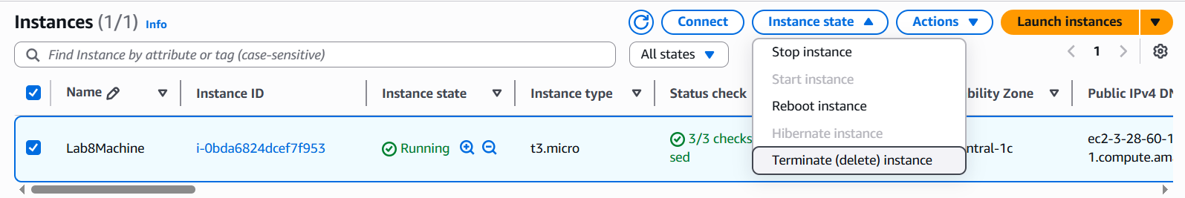
- Deleted attached EBS volumes & snapshots.
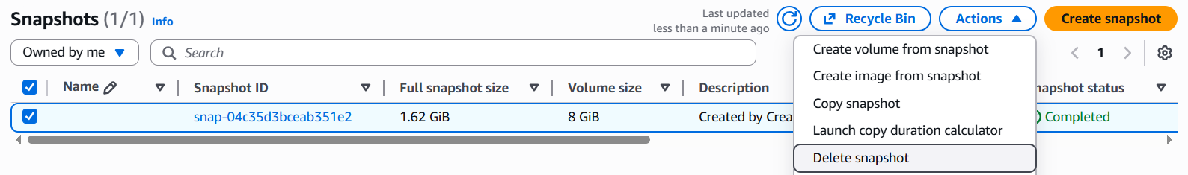
- Deleted Lab8SecurityGroup and Lab8Key.
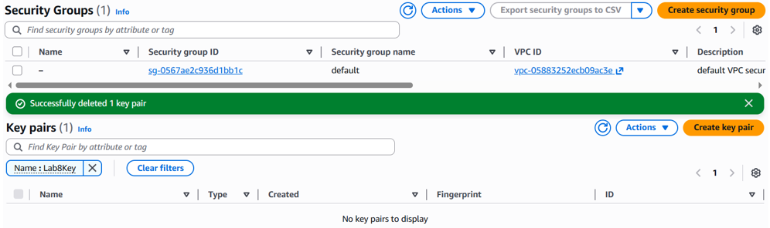
- Deleted IAM user Lab8User.
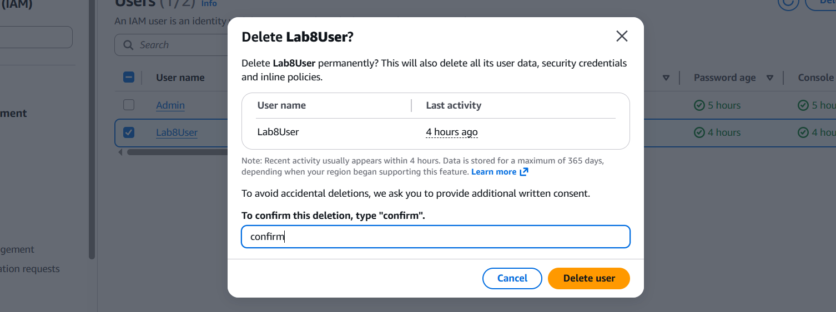
- Verified no active resources remained.
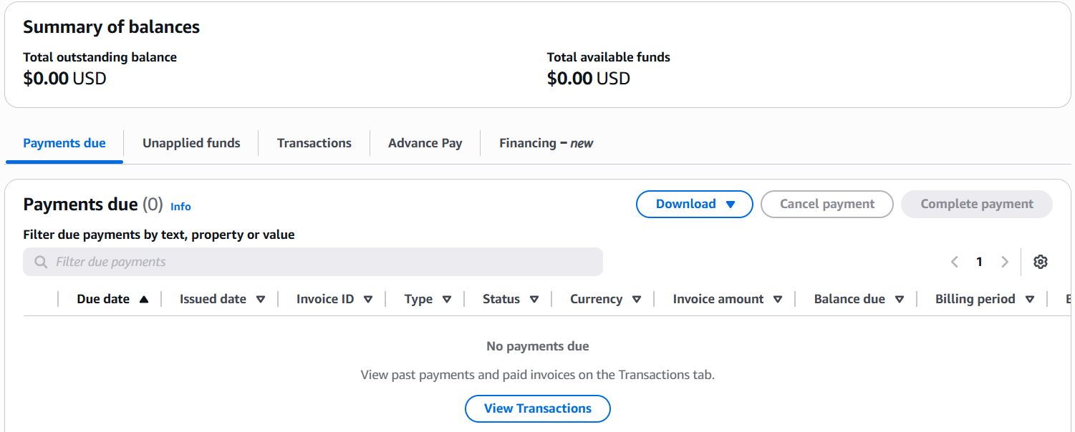
Outcome:
All AWS resources were safely removed and no active services remained.

